Arab American University of Palestine
Faculty of Artificial Intelligence
Artificial Intelligence Department

Project Title:
Darb Web-App
Prepared By:
Anas Musleh (Project Manager): 202411055
Baraa Albzour: 202411378
Dana Zakarna 202411434
Hala Qasrawi 202410833
Supervisor:
Dr. Anjad Badran

Table of Contents
Phase1: Project Overview and System Analysis
1.1 Introduction 3
1.2 Objectives………………………………………………………………………………………………3
1.3 Why this project………………………………………………………………………………...……4
1.4 problem statement ……………………………………………………………………………….…4
1.5 Target Users / Stakeholders……………………………………………………………………....5
1.6 Innovation / Differentiation…………………………………………………………………...…..5
1.7 Existing Solutions / Market Research………………………………………………….……....5
1.8 solution……………………………………………………………………………………………….….6
1.9 Key features………………………………………………………………………………………….….6
1.10 Case Studies…………………………………………………………………………………………..7
phase 2: Software Process Model Selection
2.1 Model Selection……………………………………………………………………………………….10

2.1.1 Incremental Model ………………………………………………………………………………...11

2.1.2 Waterfall Model………………………………………………………………………………………11
2.1.3 Justification for Model Selection……………………………………………………………….12

2.1.4 Comparison of Models…………………………………………………………………………….12
2.1.5 Advantages and Possible Limitations…………………………………………………………13
2.2 Project Plan………………………………….…………………………………………………………....14
2.2.1 Analysis Plan…………………………………………………………………………………………14
2.2.2 Development Plan………………………………………………………………………………….15
2.2.3 Testing Plan…………………………………………………………………………………………..16
2.3 Timeline and Scheduling ………………………………………………………………………………17
2.3.1 Work Breakdown Structure ………………………………………………………………….…..17
2.3.2 Milestones and Deadlines………………………………………………………………………..18
2.3.3 Time and Effort Estimation……………………………………………………………………….19
2.3.4 Timeline Justification……………………………………………………………………………….19
2.4 Jira Project Management………………………………………………………………………………..19

1.1 Introduction:

Darb is a web app that helps users reach places as fast as possible, especially in emergency cases. The main idea is that the web app works even without internet, so users can still use it anytime.
The web app is built using HTML, CSS, and JavaScript, so it works on any browser without downloading. It saves important data locally on the device using SQLite, and when internet is available, it updates data using Firebase.

1.2 Objectives:
The main goals of the Darb web app are:

1. Help users find the nearest medical center very quickly.
2. Keep the design simple for everyone.
3. Make the app work without internet.
4. Update data when internet is available.
5. Make the system reliable.

1.3 Why This Project?

We chose this project because it solves a real problem in daily life. In many places, internet is weak or not available, which makes normal apps hard to use.
This web app can save time and help people in emergencies. It also helps us use what we learned in programming and system design.

1.4 Problem statement:
Users face these problems:

1. Hard to find nearest medical center quickly.
2. No Internet in some places and in some cases, even if the internet is available, it will be cut off (such as in areas near checkpoints).
3. Searching takes time.
4. Limited navigation options.
5 .These problems are serious in emergency cases.

1.5 Target Users / Stakeholders:
The web app is useful for:
- All users.
- Patients.
- Drivers.
- People without good internet.

1.6 Innovation / Differentiation:
What makes Darb special:

1. Works without internet -The most important feature-.
2. Has one-click emergency button.
3. Simple and fast.
4. Made for emergency use.

1.7 Existing Solutions / Market Research:
- Apps like Google Maps, Waze, Apple Maps, and HERE WeGo help with navigation.
- They need internet to work properly.
- They are not made for emergencies.
- They don’t work fully offline.
- This shows a gap in existing solutions for an offline emergency navigation system, which is what Darb aims to provide.

1.8 Solution:

Darb solves this by:

1. Saving data on the device.
2. Working fully offline.
3. Updating when internet is back.
4. Using a fast way to find nearest place.

1.9 Key features:

=> Works without internet when you are in the public areas.
=> Find nearest medical center.
=> Fast performance.
=> Web app.
=> Data update.
=> Simple chatbot.
=> Easy design.
=> Ready Chatbot Prompts.

Case Studies:

To ensure proper system development and clear requirement definition, the project is structured using User Stories and Tasks. This approach helps in organizing features from the user's perspective and breaking them down into implementable steps.
The system features are defined using user stories following Agile practices, where each story represents a user need and is broken down into smaller implementation tasks.

User Story 1: Find Nearest Medical Center

User Story:
As a user, I want to find the nearest medical center quickly so that I can reach it in emergency situations.

Tasks:
1. Get user location (GPS or stored location).
2. Retrieve medical centers from local database.
3. Calculate distance between user and centers.
4. Sort results based on distance.
5. Display the nearest center on the map.
6. Show basic details (name, distance, location).
User Story 2: Use Application Offline
User story:
As a user, I want to use the application without internet so that I can access it anytime.

Tasks:
1. Store data locally using SQLite.
2. Load data from local storage.
3. Ensure all features work offline.
4. Detect online/offline status.
5. Auto switch between modes.
6. Cache essential data.
7. Store map data locally.
8. Show offline indicator.

User Story 3: One-click Emergency Feature
User story:
As a user, I want a one-click emergency feature so that I can save time.
Tasks:
1. Design Emergency button in UI/UX.
2. Detect user location instantly.
3. Automatically find nearest medical center.
4. Start navigation immediately.
5. Skip unnecessary steps (optimize speed).
6. Highlight route clearly on the map.
User Story 4: Voice Navigation Instructions

User story:
As a user, I want voice navigation instructions so that I can follow directions without looking at the screen while moving.

Tasks:
1. Integrate a text-to-speech engine into the web app.
2. Ensure full offline functionality using pre-downloaded voice packs.
3. Convert route steps (e.g., turn left/right, distance) into structured voice instructions.
4. Store and manage required voice packs locally.
5. Provide user settings for voice (enable/disable, volume, speed).

User story 5: Chatbot support

User story:
As a user, I want a chatbot that provides quick navigation help so that I can reach my destination faster without searching manually:

Tasks:
1. Design chatbot interface.
2. Add predefined response templates.
3. Provide quick actions (nearest hospital, emergency route).
4. Ensure chatbot works offline using stored templates.
5. Optimize for fast response time.

Phase 2: Software Process Model Selection:

2.1 Model Selection
For the Darb web app, the team adopted a Hybrid Software Process Model:
- Incremental Model (Main Model)
- Waterfall Model (Supporting Model)

Rationale for Selection:
The Darb system is composed of multiple independent modules such as location tracking, medical centers database, offline functionality, emergency navigation, and voice guidance. Since these components can be developed separately and gradually, the Incremental Model is the most appropriate main approach.
At the same time, the project requires clear and well-structured documentation, including requirements analysis and system design, especially with a medical system existing, which is better handled using the Waterfall Model during the initial phase.

2.1.1 Incremental Model (Main Model):
The system will be developed in successive increments, where each increment delivers a functional part of the application:
1. Project setup and basic UI/UX.
2. User location detection and map integration.
3. Medical centers database and nearest location feature.
4. Offline functionality using SQLite.
5. Emergency one-click feature.
6. Voice navigation and system optimization.

- Each increment includes development, testing, and integration.

2.1.2Waterfall Model (Supporting Model):
The Waterfall approach is applied in the early stages of the project as follows:
1. Requirements Analysis.
2. System Design (architecture, database design, UI/UX).
3. Initial documentation and planning

2.1.3 Justification for Model Selection

The Hybrid Model (Incremental + Waterfall) fits the Darb project because it gives us both structure and flexibility.
Darb has several separate features since these features can be built one by one, the Incremental Model is a good fit because it allows us to develop the system step by step and test each part before moving to the next.
At the same time, the project also needs clear planning and proper documentation, especially for requirements and system design. This is where the Waterfall Model helps, because it gives us a clear structure in the beginning before development starts.
That is why combining both models is the best choice for Darb.

2.1.4 Comparison of Models:

Incremental Model:
1. Allows step-by-step development.
2. Each module is tested separately.
3. Suitable for web app and evolving systems.
Waterfall Model:
1. Structured and sequential approach.
2. Strong focus on documentation.
3. Suitable for requirements and design phase.

2.1.5 Advantages and Possible Limitations:

1. The Hybrid Model has several advantages for the Darb project.
2. It gives us a clear plan at the beginning, which helps the team understand the system before starting development.
3. It also allows us to build the project step by step, making development easier and more organized.
4. Another advantage is that each feature can be tested early, which helps us find problems faster and improve the system gradually.
5. This model also fits both academic needs and real development practice, since it supports documentation and actual implementation at the same time.

However, it also has some limitations:
1. Using two models together needs better coordination between planning and development.
2. It can also take more effort because the team needs to manage both documentation and implementation at the same time.
3. Still, these limitations are manageable, and overall the Hybrid Model is the best fit for Darb.

2.2 Project Plan (Final Version – Web App | Hybrid Model):
The project plan for the Darb system is based on a Hybrid Model combining Waterfall and Agile methodologies. Waterfall is used for overall phase structuring, while Agile (Scrum) is used for iterative development.

2.2.1 Analysis Plan:
The analysis phase focuses on understanding the problem, defining requirements, and preparing system specifications.
Activities:

1. Define the problem and project goals.
2. Conduct market research.
3. Define functional requirements (nearest medical center, emergency mode, offline access, chatbot).
4. Define non-functional requirements (performance, speed, usability, offline support).
5. Identify target users and stakeholders.
6. Prepare SRS document.
7. Define user stories and backlog.

2.2.2 Development Plan:
The development phase follows an Agile approach and is implemented as a Web App using HTML, CSS, and JavaScript.

Activities:
- Set up web development environment (HTML, CSS, JavaScript).
- Design system architecture (Frontend + Local Storage layer).
- Implement core system features in iterative sprints:

User location detection using Browser Geolocation API.
1. storage using Indexed DB / Local Storage.
2. Medical centers database management.
3. Nearest medical center calculation (distance algorithm).
4. Emergency one-click feature.
5. Responsive web interface (mobile + desktop support).
6. Rule-based chatbot using predefined templates.
Sprint planning, development, and review cycles.
Continuous integration and feature enhancement.

Sprint Structure:
- Sprint 1:

- Project setup.
- UI/ UX design.
- Geolocation integration.

- Sprint 2:

- Medical database (offline storage).
- Nearest location algorithm.

- Sprint 3:
- Emergency mode implementation.
- Offline functionality enhancement.

- Sprint 4:
- Chatbot prompts templates.
- UI/UX improvements.

2.2.3 Testing Plan:
The testing phase ensures system reliability, correctness and offline functionality.

Activities:
1. Unit testing for core functions (e.g., distance calculation).
2. Integration testing between modules (UI + logic + storage).
3. System testing for full application workflow.
4. Offline functionality testing (critical requirement).
5. Browser compatibility testing (Chrome, Firefox, Edge).
6. Performance testing (response time and speed optimization).
7. Bug fixing and regression testing.

Test Scenarios:
- Application works without internet connection.
- Correct nearest medical center is displayed.
- Emergency button responds instantly.
- Data is correctly retrieved from local storage.
- Chatbot responses work without delay.

2.3 Timeline and Scheduling:

2.3.1 Work Breakdown Structure (WBS)
To ensure proper project organization and execution, the Darb application is divided into the following phases and tasks:

1. Planning Phase:
- Define project ideas.
- Identify target users.
- Conduct market research.
- Define system objectives.

2. Analysis Phase:
- Gather system requirements.
- Define functional requirements.
- Define non-functional requirements.

3. Design Phase:
- Design system architecture.
- Create UML diagrams (Use Case, Class, Sequence).
- Design database (ERD).
- Create UI wireframes and prototypes.

4. Development Phase:
- Set up development environment (Web technologies such as HTML, CSS, JavaScript, and backend services).
- Implement local data storage and caching mechanisms.
- Develop nearest location detection algorithm.
- Design and implement web-based user interface.
- Implement emergency features.
- Implement voice navigation system.

5. Testing Phase:
- Create test cases.
- Perform unit testing.
- Perform integration testing.
- Fix bugs and optimize performance.

6. Deployment and Presentation Phase:
- Final system integration.
- Deploying the web app.
- Prepare final presentation.
- System demonstration.

2.3.2 Milestones and Deadlines:
The project follows an 8 weeks timeline to simulate a realistic software development lifecycle:
Milestone | Description | Duration
M1 | Project Proposal & Idea Approval | Week 1
M2 | Requirements Analysis (SRS) | Week 2
M3 | System Design Completion | Week 3
M4 | Core Development (Web System + Database) | Week 4 - 5
M5 | Advanced Features (Emergency + Voice Navigation) | Week 6
M6 | Testing & Bug Fixing | Week 7
M7 | Final Deployment & Presentation | Week 8

2.3.3 Time and Effort Estimation:
The estimated time for each phase is as follows:
Phase | Estimated Duration
Planning & Analysis | 1 week
Analysis | 1 week
Design | 1 week
Development | 2 weeks
Advanced Features | 1 week
Testing | 1 week
Final Preparation | 1 week

2.3.4 Timeline Justification:
The project timeline is limited to 8 weeks to match the academic semester.
This schedule is shorter than a real industry timeline, so the team will follow a compressed plan focused on the most important features.
The 8-week plan is enough to complete the core system, test it properly, and deliver a working final version on time
2.4 Jira Project Management:
Jira will be used as the main project management tool throughout the Darb project.
It will help the team organize tasks, track progress, and manage the project based on the Hybrid Model.
How Jira Will Be Used:
- Create project backlog.
- Define epics and tasks.
- Assign team responsibilities.
- Track progress weekly.
- Manage milestones and deadlines.
- Monitor testing and bug reports.
- Document sprint reviews and updates.
Phase 3: Requirements Analysis (SRS)
Software Requirement Specification (SRS):

3.1 System Requirements
Hardware Requirements
- Smartphone, tablet or computer.
- GPS support for location detection.
- Minimum 2GB RAM for smooth performance.
Software Requirements
- Modern web browser (Chrome, Firefox, Edge).
- HTML, CSS and JavaScript support.
- Local storage support (SQLite).
- Firebase for online synchronization when internet is available.
3.2 User Requirements
The system is designed to meet the following user needs:
- Users should be able to quickly find the nearest medical center.
- Users should be able to use the system without internet connection.
- Users should have access to an emergency one-click feature.
- Users should receive simple and fast navigation guidance.
- Users should be able to use a basic chatbot for assistance.
- Users should interact with a simple and easy interface without complexity.
3.3 Functional Requirements
1. Location Detection:
The system shall detect the user’s current location using GPS or the browser geolocation API.
2. Nearest Medical Center:
The system shall calculate the nearest medical center based on the user’s location.
The system should sort medical centers according to distance.
3. Offline Mode:
The system should store medical center data locally on the device.
The system should operate fully without internet connection.
The system shall synchronize data when internet becomes available.
4. Emergency Mode:
The system should provide a one-click emergency button.
The system shall instantly detect the user’s location.
The system shall automatically navigate to the nearest medical center.
The system shall minimize steps to ensure fast response time.
5. Navigation System:
The system shall display route directions to the selected medical center.
The system should provide step-by-step navigation instructions.
6. Voice Navigation:
The system shall convert navigation steps into audio instructions.
The system shall allow users to enable or disable voice guidance.
7. Chatbot:
The system should include a rule-based chatbot.
The chatbot shall provide predefined responses for navigation support.
The chatbot should function offline using stored templates.

3.4 Non-Functional Requirements

1. Performance:
The system shall respond within a few seconds during emergency usage.
Distance calculation shall be optimized for fast processing.
2. Usability:
The system should have a simple and user-friendly interface.
The system should be suitable for all types of users including non-technical users.
3. Reliability:
The system should operate without internet connection.
The system shall maintain data consistency during synchronization.
4. Availability:
The system shall be available 24/7.
Offline functionality ensures continuous availability.
5. Portability:
The system should run on all modern web browsers.
No installation shall be required.
6. Security:
User location data shall be stored locally on the device.
No sensitive data shall be shared externally.

3.5 Use Case Descriptions
Use Case 1: Find Nearest Medical Center
Prepared by: Anas Musleh
Description: This use case allows the user to find the closest medical center based on their current location. The system works even without internet.
Preconditions: The app is open and location permission is turned on.
Main Flow:
- The user asks to find the nearest medical center.
- The system gets the user’s location.
- The system reads saved medical centers from the device.
- The system calculates the closest center.
- The system sorts of centers from closest to farthest.
- The system shows the nearest medical center on the map.
Alternative Flow A: Location Not Allowed
- The system shows a message asking the user to enable location.
- The user can choose location manually.
- The system continues using the selected location.
Alternative Flow B: No Data Found
- The system shows a message: “No data available offline.”
- The system asks the user to connect to internet to update data.
Postconditions: The nearest medical center is shown to the user.
Use Case 2: Emergency Mode Activation
Prepared by: Dana Zakarna
Description: This feature helps the user quickly find the nearest medical center with one click in emergency cases.
Preconditions: The app is open.
Main Flow:
- The user presses the emergency button.
- The system gets the current location.
- The system reads saved medical centers.
- The system finds the closest center.
- The system starts navigation automatically.
- The route is shown on the map.
Alternative Flow: Weak Location Signal
- The system uses the last saved location.
- The system continues navigation normally.
Postconditions: The user is guided to the nearest medical center.

Use Case 3: Offline Data Use & Sync
Prepared by: Baraa Albzour
Description: This use case allows the app to work without internet and update data when internet is back.
Preconditions: Data is already saved on the device.
Main Flow:
- The user opens the app without internet.
- The system detects offline mode.
- The system loads saved data.
- The user uses the app normally.
- When internet returns, the system connects to Firebase.
- The system updates the data.
Alternative Flow: Sync Problem
- If internet disconnects during update, the system stops safely.
- The system tries again later.
Postconditions: The app works offline and updates data when internet is available.

Use Case 4: Voice Navigation
Prepared by: Hala Qasrawi
Description: This feature reads navigation steps as audio so the user can follow directions without looking at the screen.
Preconditions: A route exists.
Main Flow:
- The system creates route steps.
- The system converts steps to text.
- The system reads the text as voice.
- The user follows the voice instructions.
Alternative Flow: Voice Off
- The system stops audio.
- The system shows only written directions.
Postconditions: The user gets voice directions.

Use Case 5: Chatbot Help
Prepared by: Team Collaborative
Description: This feature helps the user by giving quick answers using simple chatbot buttons.
Preconditions: The app is open.
Main Flow:
- The user opens the chatbot.
- The system shows quick options.
- The user selects a question (example: nearest hospital).
- The system gives the answer or starts navigation.
Alternative Flow: Unknown Question
- The system cannot understand the input.
- The system shows: “Please use quick buttons for help.”
Postconditions: The user gets fast help.
3.6 Use Case Diagram: 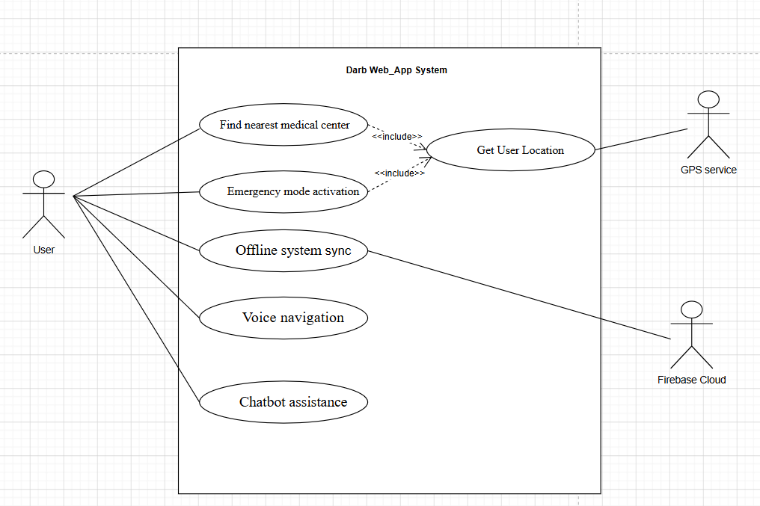

Phase 4: System Design

4.1 System Context Description
The Context of the Darb Web-App defines the system boundary and its interaction with external entities. The system is designed to assist users in finding the nearest medical centers efficiently, especially in emergency situations.
The main interaction occurs between the User and the Darb Web-App System, where the user sends location data and requests, and the system responds with navigation guidance and medical center information.
Additionally, the system interacts with external services such as Firebase Cloud Database for data synchronization when internet is available, while maintaining a Local Database (SQLite) for offline functionality.

System Context Diagram:

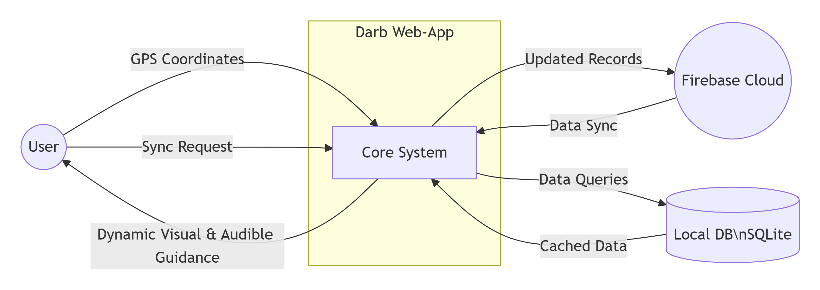

4.2 System Architecture Overview
The Darb Web-App follows a modular architecture composed of independent components that work together to provide a seamless user experience. The main components include:
- User Interface (UI Layer)
- Navigation Engine
- Local Database Manager
- Voice Navigation Engine
- Chatbot Module
This modular structure ensures scalability, maintainability and offline functionality.

4.3 Class Design Overview
The system is structured using an object-oriented approach. The main classes and their responsibilities are as follows:
User Class:
Represents the system user and handles location updates and emergency actions.
Medical Center Class:
Represents medical center data including name, location coordinates, and contact information.
Navigation Engine Class:
Responsible for calculating distances, identifying the nearest medical center, and generating routes.
Database Manager Class:
Manages local storage of medical center data and handles synchronization with cloud storage when available.
Voice Synthesis Engine Class:
Handles conversion of navigation instructions into audio output for voice guidance.
Chatbot Manager Class:
Provides predefined responses and assists users with quick navigation-related queries.

Activity Diagram:
1. Find Nearest Medical Center:
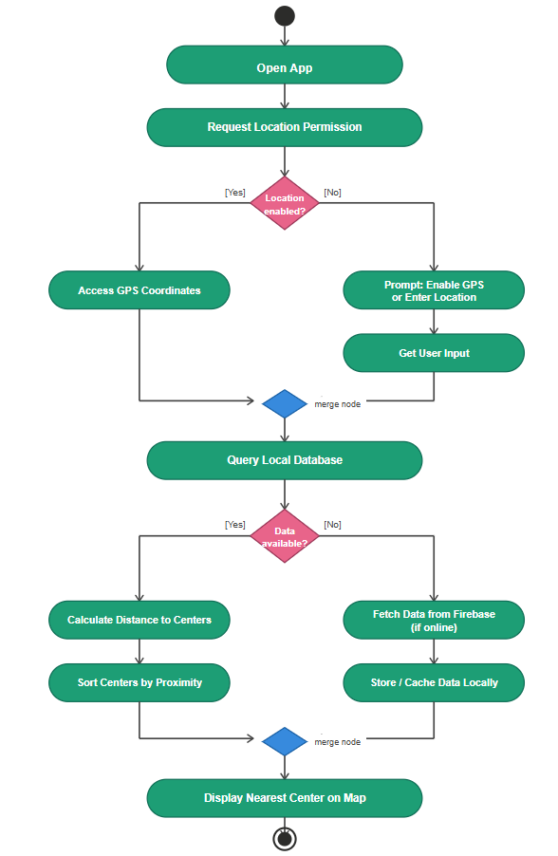

2. Offline Data Synchronization:

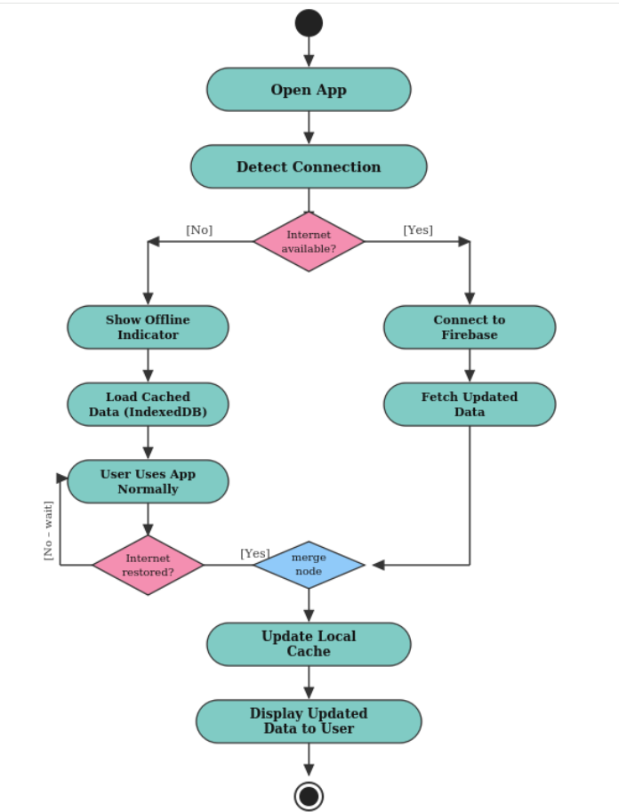

Class Diagram:
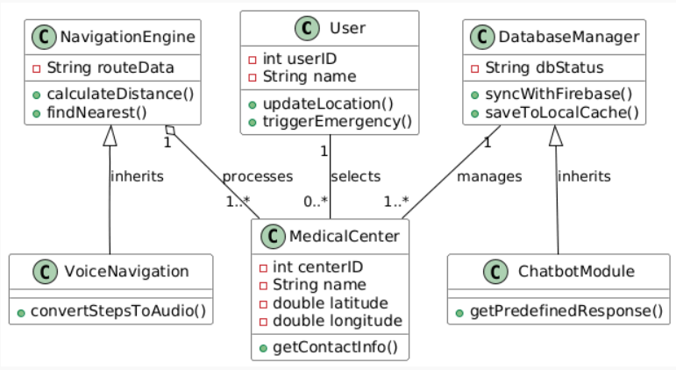

Sequence Diagram: 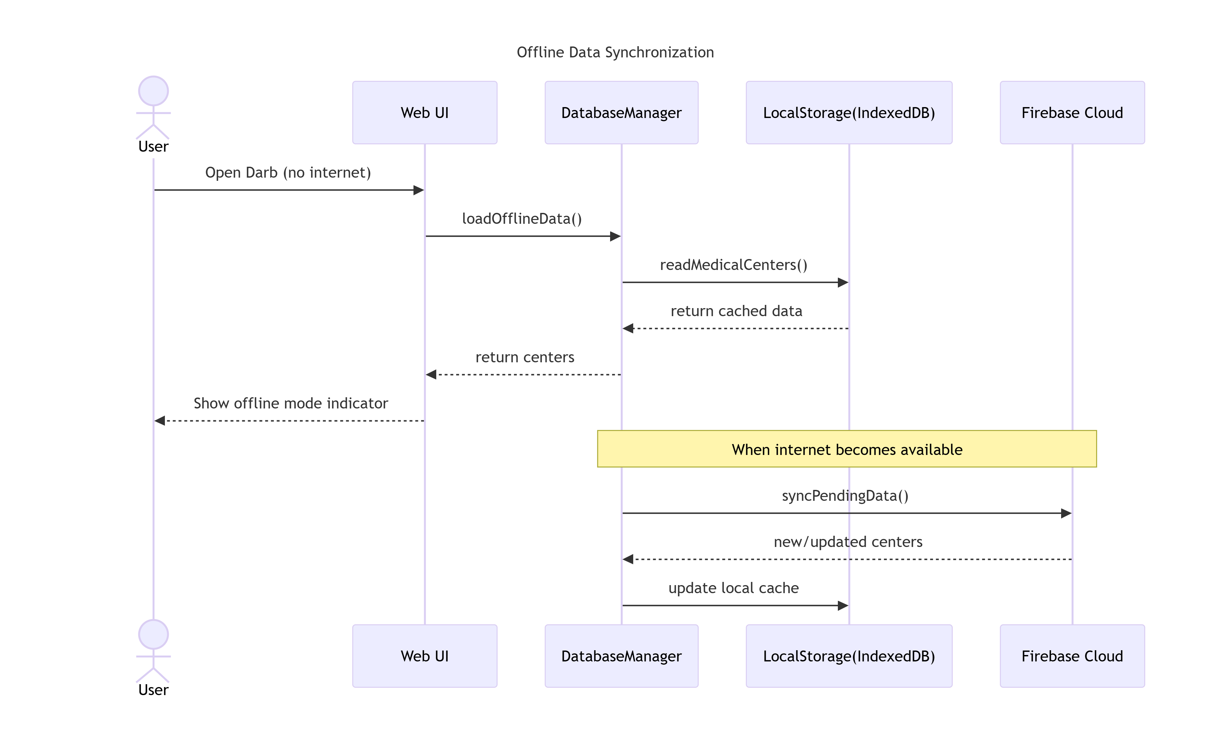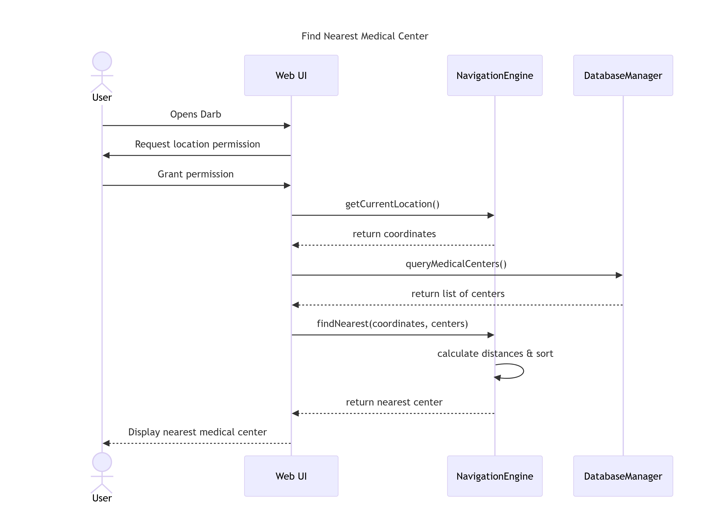
4.8 Conclusion:

The system design of the Darb Web-App provides a complete architectural structure that supports emergency navigation, offline functionality and user-friendly interaction. The modular approach ensures scalability and efficiency, making the system suitable for real-world emergency use cases.

